I installed the VS CODE IDE and currently doing course projects on it.

Glad I did it seamlessly

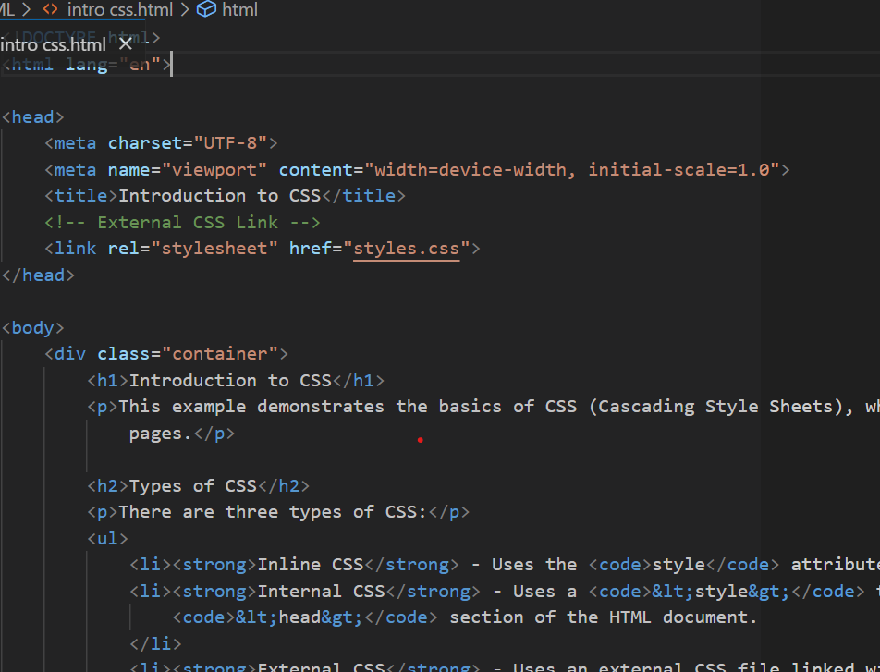

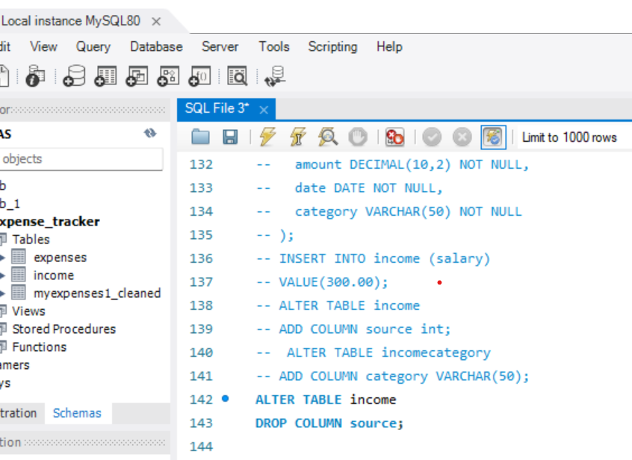

Here is MYSQL workbench  
configured and working properly